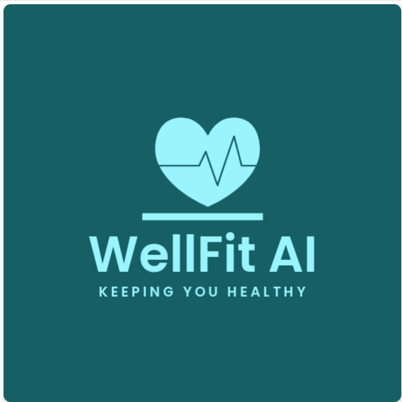

**Project Vision**

**2nd February 2025**

**Version 1.0**

Document History

|  |  |  |  |  |
| --- | --- | --- | --- | --- |
| **No** | **Date** | **Author** | **Description** | **Version** |
| **1** | 01 Jan 2025 | Akshay Kapoor | Initial Draft | 0.1 |
| **2** | 01 Jan 2025 | Shilpa Sosa George | Added “3.0 Stakeholder Analysis” | 0.2 |
| **3** | 01 Jan 2025 | Labdhi Bharat Shah | Added “5.0 Comparison Plan” | 0.3 |
| **4** | 01 Jan 2025 | Musaab Shirgar | Updated “2.0 Solution Overview” as per feedback from team | 0.4 |
| **5** | 02 Jan 2025 | Parbon Bannerjee | Added “4.0 Solution Scope” | 0.5 |
| **6** | 02 Jan 2025 | Nishita Ahuja,  M. Asad Bin Faruq | Final review, formatting changes. | 1.0 |

Table of Contents

**1** **Introduction** 1

**2** **Solution Overview** 1

**2.1** **Problem Statement** 1

**2.2** **Problem Statement Template** 1

**2.3** **Solution** 1

**2.4** **Solution Decomposition** 2

**2.5** **Technology** 2

**2.6** **Goal** 2

**3** **Stakeholder Analysis** 4

**3.1** **Stakeholder Onion Diagram** 4

**3.2** **Stakeholder List & Roles** 5

**4** **Solution Scope** 6

**4.1** **Solution Features & Functions** 7

**5** **Comparison Analysis** 7

**5.1** **Why Choose WellFit AI?** 7

**5.2** **Business Analysis Work Plan** 8

**6** **Additional Content** 10

**6.1** **Brainstorming** 10

**6.2** **References** 11

# **Introduction**

The purpose of this document is to outline the project vision for WellFit AI, a fitness and wellness application utilizing AI-powered technology. This document provides a high-level description of the solution, its stakeholders, functional decomposition, competitive analysis, and a business analysis work plan for successful implementation.

# **Solution Overview**

## **Problem Statement**

The problem of managing fitness routines, tracking exercises, calorie intake, and hydration levels effectively affects fitness enthusiasts of all levels, from beginners to professional athletes.  
The impact of this is inconsistent progress, lack of motivation, and difficulty in achieving fitness goals.  
A successful solution would provide AI-powered real-time feedback on exercise form, monitor calorie intake and hydration, and generate personalized fitness routines to help users achieve their health goals with ease and precision.

## **Problem Statement Template**

|  |  |
| --- | --- |
| The problem of | Managing fitness routines, tracking exercises, calorie intake, and hydration levels effectively. |
| **Affects** | Fitness enthusiasts of all levels, from beginners to experienced athletes. |
| **The Impact of which Is** | Inconsistent progress, lack of motivation, and difficulty in achieving fitness goals. |
| **A successful solution would** | Provide real-time feedback on exercise form using AI-powered motion tracking, monitor calorie intake and hydration, and suggest personalized fitness routines to help users achieve their goals with ease and precision. |

## **Solution**

**WellFit AI** is an AI-assisted fitness application designed for fitness enthusiasts, athletes, fitness and wellness centers, personal trainers, and beginners who aim to achieve their fitness goals without sacrificing time or convenience.

The application leverages AI-powered technology to observe body movements, such as counting push-up reps, monitoring calorie intake, and managing hydration levels. After analyzing water and calorie intake, WellFit AI provides a tailored set of exercises to suit individual fitness needs.

Each exercise comes with a short instructional video to guide users through proper techniques and ensure maximum effectiveness, making fitness accessible and personalized for everyone.

## **Solution Decomposition**

|  |  |
| --- | --- |
| For | Fitness enthusiasts of all levels. |
| **Who** | Want to effectively track their workouts, calorie intake, and hydration levels to achieve their fitness goals. |
| **Product Name** | WellFit AI |
| **That** | Tracks workouts using AI-powered movement recognition, monitors calorie intake and hydration, and provides personalized fitness routines. |
| **Unlike** | Other fitness apps on the market provide only generic plans or track time. |
| **Our Product** | Is a comprehensive wellness platform that combines AI-powered training with personalized nutrition guidance for a complete approach to health and fitness. |

## **Technology**

WellFit AI leverages the following technologies to deliver a unique and effective fitness experience:

* **AI-Powered Motion Tracking:** Advanced computer vision algorithms analyze user movements during exercise, providing real-time feedback on form and technique. This helps users perform exercises correctly, maximizing results and minimizing the risk of injury.
* **Calorie and Hydration Monitoring:** WellFit AI integrates with nutrition databases to track calorie intake and hydration levels. This data is used to personalize fitness routines and provide insights into overall health and wellness.
* **Personalized Fitness Plans:** AI algorithms analyze user data, including fitness goals, activity levels, and dietary preferences, to generate customized workout and nutrition plans. These plans adapt to user progress, ensuring continued engagement and optimal results.

By combining these technologies, WellFit AI offers a comprehensive and personalized fitness solution that empowers users to achieve their health goals and transform their lives.

## **Goal**

The goal of WellFit AI is to empower fitness enthusiasts of all levels to achieve their health and wellness goals by providing a comprehensive, personalized, and engaging fitness experience.

**Intended Use:**

WellFit AI is intended to be used as a primary fitness companion for individuals who want to:

* **Track their workouts effectively:** The app uses AI-powered movement recognition to accurately monitor exercise form and repetitions, providing valuable insights into workout performance.
* **Monitor calorie intake and hydration:** WellFit AI helps users track their calorie consumption and hydration levels, enabling them to make informed choices that support their fitness goals.
* **Follow personalized fitness routines:** The app generates customized workout and nutrition plans based on individual goals, preferences, and progress, ensuring an optimized and engaging fitness journey.
* **Stay motivated and consistent:** WellFit AI provides progress tracking, goal setting tools, and reminders to help users stay on track and achieve their desired results.

In addition to individual use, WellFit AI can also be utilized by:

* **Personal trainers and fitness centers:** To deliver personalized fitness plans and track client progress.
* **Nutritionists and dieticians:** To integrate personalized diet plans into the fitness routines.

By catering to a wide range of users and use cases, WellFit AI aims to become an indispensable tool for anyone seeking to improve their health and wellness.

# **Stakeholder Analysis**

## **Stakeholder Onion Diagram**

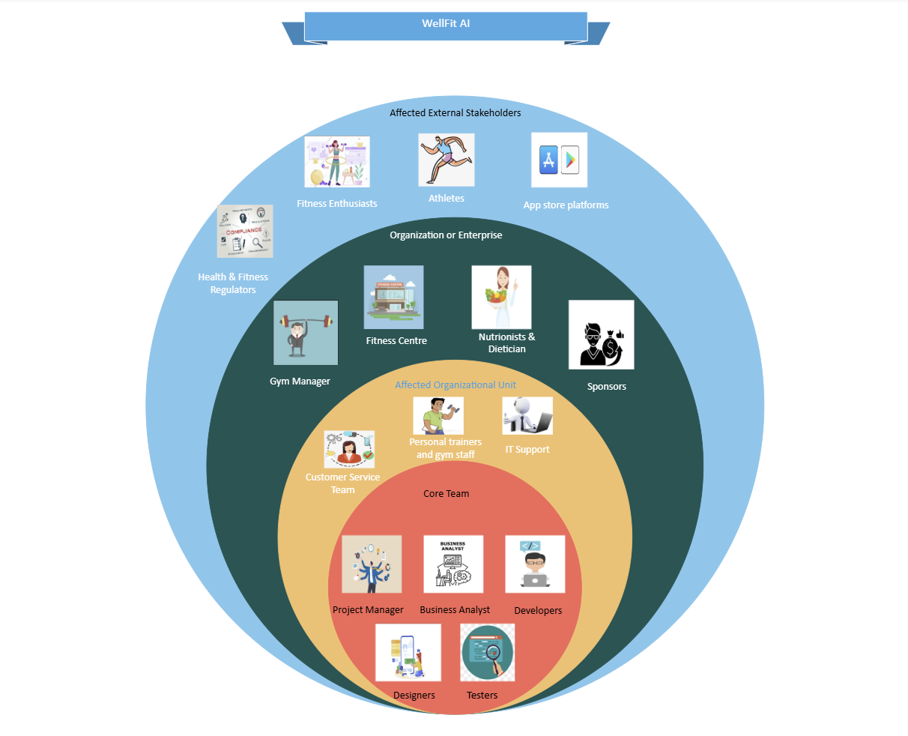

## **Stakeholder List & Roles**

|  |  |  |
| --- | --- | --- |
| **Stakeholder Group** | **Stakeholder** | **Impact/Interest/Role** |
| Core Team | Project Manager | Oversee app development, manage timelines, and ensure alignment with stakeholder requirements. |
| Core Team | Business Analyst | Gathers and documents requirements, ensuring the app aligns with user needs. |
| Core Team | Developers | Build and maintain AI-powered features for fitness tracking and personalized plans. |
| Core Team | Designers | Create user-friendly interfaces and design a seamless user experience. |
| Core Team | Testers (QA Team) | Ensure the app meets quality standards and is free of bugs or issues before deployment. |
| Organizational Unit | Customer Service Team | Address user issues, provide guidance, and relay user feedback for improvements. |
| Organizational Unit | Personal Trainers and Gym Staff | Use the app to deliver personalized fitness plans and track member progress. |
| Organizational Unit | IT Support | Ensure technical stability and resolve any infrastructure-related issues. |
| Enterprise | Gym Owners and Managers | Provide operational feedback, ensure app integration in gym operations, and promote the app among members. |
| Organization or Enterprise | Sponsors and Advertisers | Provide financial backing, collaborate on marketing campaigns, and use the app for branding opportunities. |
| Organization or Enterprise | Fitness Centers | Serve as the primary venue for app usage, offering value-added services to members. |
| Organization or Enterprise | Nutritionists and Dietitians | Contribute expertise for personalized diet plans and fitness goals within the app. |
| Organization or Enterprise | Health & Fitness Regulators | Ensure compliance with industry standards and promote trust in the app's offerings. |
| External Stakeholders | Fitness Enthusiasts | Use the app for AI-driven tracking, personalized plans, and progress monitoring. |
| External Stakeholders | Athletes | Utilize advanced tracking features for optimizing performance and training. |
| External Stakeholders | App Store Platforms | Host and distribute the app, manage updates, and drive visibility among users (Google Play Store, Apple app store) |

# **Solution Scope**

Functional Decomposition Diagram

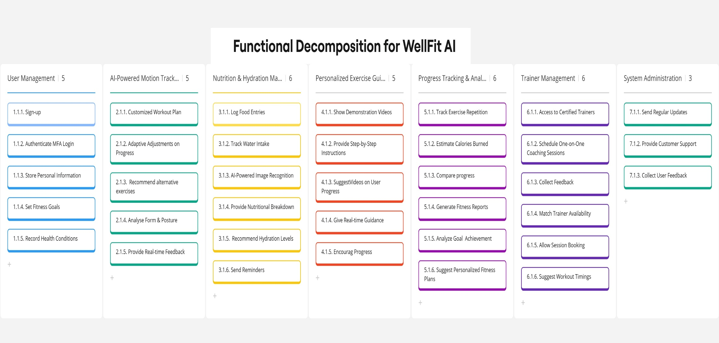

## **Solution Features & Functions**

* **AI Recommendations –** Suggest new exercises based on user progress.
* **AI-Powered Movement Tracking –** Counts reps and tracks form for exercises like push-ups and squats.
* **Calorie and Hydration Monitoring –** Logs daily intake and adjusts workout recommendations accordingly.
* **Progress Insights & Analytics –** Provides visual tracking of fitness journey.
* **Personalized Fitness Plans –** Custom workout and nutrition plans based on user goals.
* **Goal Setting & Reminders –** Encourages consistency through alerts and reminders.
* **Sleep Tracking –** Monitors sleep to optimize recovery and adjust workouts.
* **Short Instructional Videos –** Ensures proper exercise technique.

# **Comparison Analysis**

|  |  |  |  |
| --- | --- | --- | --- |
| **Feature** | **WellFit AI** | **GoodLife Fitness** | **Fitbit** |
| AI Recommendations | ✅ | ❌ | ❌ |
| AI-Powered Movement Tracking | ✅ | ❌ | ✅ |
| Calorie and Hydration Monitoring | ✅ | ❌ | ✅ |
| Progress Insights & Analytics | ✅ | ✅ | ✅ |
| Goal Setting & Reminders | ✅ | ✅ | ✅ |
| Personalized Fitness Plans | ✅ | ❌ | ✅ |
| Book Gym Classes | ❌ | ✅ | ❌ |
| Short Instructional Videos | ✅ | ❌ | ❌ |
| Sleep Tracking | ✅ | ❌ | ✅ |
| Wellness Reports | ✅ | ❌ | ✅ |

## **Why Choose WellFit AI?**

WellFit AI stands out from competitors by offering a **complete wellness platform** that integrates **AI-driven movement tracking, nutrition monitoring, sleep tracking, and personalized fitness recommendations** in a single application.

## **Business Analysis Work Plan**

|  |  |  |  |  |  |
| --- | --- | --- | --- | --- | --- |
| **Ref ID** | **Work Package** | **Activity** | **Task** | **Assigned to** | **Target Complete Date** |
| 1 | Project Proposal & Vision |  |  |  |  |
| 1.1 | Part 1 - Proposal Presentation |  |  |  |
| 1.1.1 | Team Work Session 1 | Team | 15-Jan-25 |
| 1.1.2 | Draft Presentation | Parbon & Shilpa | 16-Jan-25 |
| 1.1.3 | Team Review Presentation | Labdhi & Musaab | 17-Jan-25 |
| 1.1.4 | Presentation Day | Akshay & Asad | 18-Jan-25 |
| 1.1.5 | Professional Review | Akshay & Asad | 18-Jan-25 |
| 1.1.6 | Proposal Submission | Nishita | 19-Jan-25 |
| 1.2 | Part 2 - Project Vision |  |  |  |
| 1.2.1 | Team Work Session 1 | Team | 26-Jan-25 |
| 1.2.2 | Stakeholder Analysis | Shilpa | 28-Jan-25 |
| 1.2.3 | Product Decomposition | Parbon | 29-Jan-25 |
| 1.2.4 | Business Analysis Work Plan | Akshay | 30-Jan-25 |
| 1.2.5 | Brainstorming for Features and Analysis | Labdhi | 30-Jan-25 |
| 1.2.6 | Draft Document | Asad & Musaab | 31-Jan-25 |
| 1.2.7 | Document Review and Testing | Asad & Musaab | 31-Jan-25 |
| 1.2.8 | Vision Submission | Nishita | 01-Feb-25 |
| 2 | Deliverable 2 - Requirement Analysis |  |  |  |  |
| 2.1 | Elicit Business Requirements |  |  |  |
| 2.1.1 | Stand up | Team | 02-Mar-25 |
| 2.1.2 | Context Diagram | Shilpa | 03-Mar-25 |
| 2.1.3 | Survey Analysis & Results | Nishita | 05-Mar-25 |
| 2.1.4 | Interview Analysis & Results | Parbon | 06-Mar-25 |
| 2.1.5 | Personas | Musaab | 07-Mar-25 |
| 2.1.6 | Scenarios | Labdhi | 07-Mar-25 |
| 2.1.7 | User Journey | Akshay | 07-Mar-25 |
| 2.1.8 | Document Review and Testing | Asad | 08-Mar-25 |
| 2.1.9 | BA Work Plan update | Asad | 08-Mar-25 |
| 2.1.10 | Document Submission | Shilpa | 09-Mar-25 |
| 3 | Deliverable 3 - Requirements Design Part 1 |  |  |  |  |
| 3.1 | Transition from Business requirements to System Specifications |  |  |  |
| 3.1.1 | Stand up | Team | 21-Mar-25 |
| 3.1.2 | User Case | Shilpa | 23-Mar-25 |
| 3.1.3 | User Story | Labdhi | 24-Mar-25 |
| 3.1.4 | User Story Map | Labdhi & Musaab | 24-Mar-25 |
| 3.1.5 | Mid – Fi Mockups & Storyboard | Musaab & Akshay | 26-Mar-25 |
| 3.1.6 | Scenarios | Parbon | 27-Mar-25 |
| 3.1.7 | Business Analysis Workplan | Asad | 28-Mar-25 |
| 3.1.8 | Document Review and Testing | Nishita | 29-Mar-25 |
| 3.1.9 | Document Submission | Nishita | 29-Mar-25 |
| 4 | Deliverable 4 - Requirements Design Part 2 |  |  |  |  |
| 4.1 | Hi-Fidelity Mockup Storyboard |  |  |  |
| 4.1.1 | Stand up | Team | 06-Apr-25 |
| 4.1.2 | Brainstorming - Innovation | Team | 08-Apr-25 |
| 4.1.3 | Mockups Quality | Labdhi & Musaab | 09-Apr-25 |
| 4.1.4 | Seamless Workflow | Shilpa & Parbon | 10-Apr-25 |
| 4.1.5 | Live Presentation | Asad & Nishita | 12-Apr-25 |
| 4.1.6 | Video Demo | Akshay | 13-Apr-25 |
| 4.1.8 | Document Review and Testing | Shilpa | 14-Apr-25 |
| 4.1.9 | Document Submission | Nishita | 16-Apr-25 |
| 5 | Deliverable 5 - Sketches |  |  |  |  |
| 5.1 | Workshop 1 - Sketches for a Mobile App |  |  |  |
| 5.1.1 | Stand up | Team | 09-Mar-25 |
| 5.1.2 | Work Flow Diagram | Every Team Member | 11-Mar-25 |
| 5.1.3 | Sketch Quality | Labdhi & Musaab | 13-Mar-25 |
| 5.1.4 | Storyboard | Shilpa, Parbon & Nishita | 14-Mar-25 |
| 5.1.7 | Document Review and Testing | Akshay & Asad | 15-Mar-25 |
| 5.1.8 | Document Submission | Nishita | 16-Mar-25 |
| 6 | Deliverable 6 - Mid Fi Prototype |  |  |  |  |
| 6.1 | Workshop 2 - Mid Fidelity for a Tablet Device App |  |  |  |
| 6.1.1 | Stand up | Team | 16-Mar-25 |
| 6.1.2 | Alignment to Sketch | Every Team Member | 18-Mar-25 |
| 6.1.3 | Quality of the Mockup | Labdhi & Musaab | 20-Mar-25 |
| 6.1.4 | Storyboard (alignment to diagram) | Shilpa, Parbon & Nishita | 21-Mar-25 |
| 6.1.5 | Document Review and Testing | Akshay & Asad | 22-Mar-25 |
| 6.1.6 | Document Submission | Nishita | 23-Mar-25 |

# **Additional Content**

## **Brainstorming**

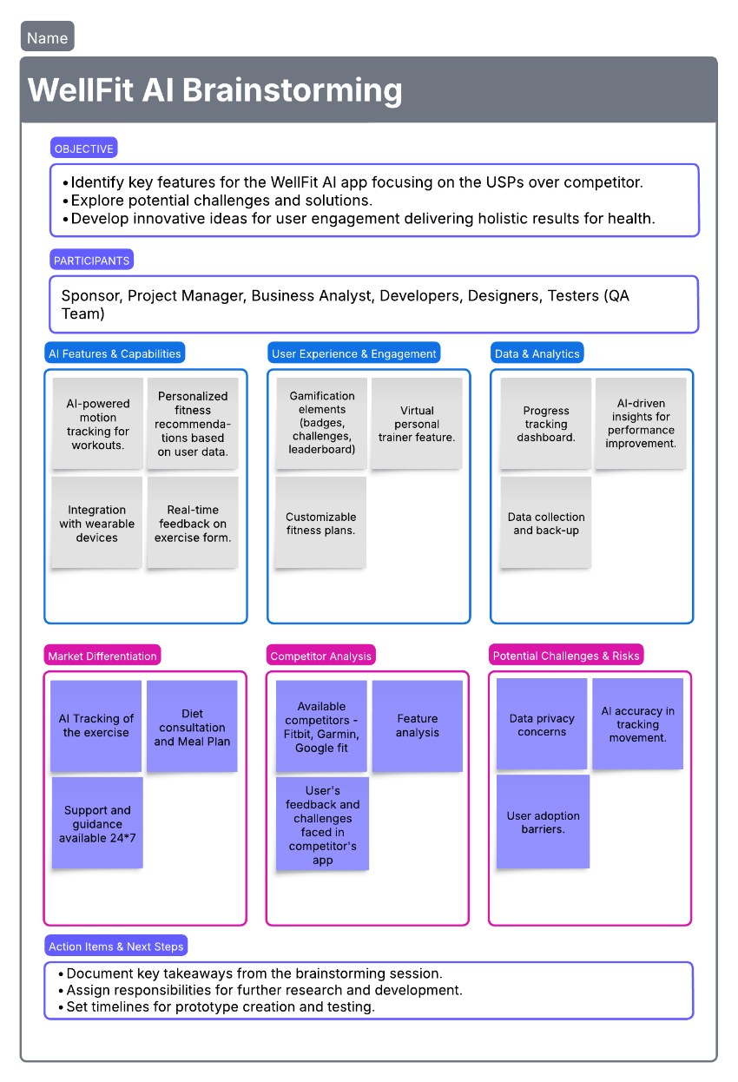

## **References**

Angosto, S., García-Fernández, J. & Grimaldi-Puyana, M. A systematic review of intention to use fitness apps (2020–2023). *Humanit Soc Sci Commun* **10**, 512 (2023). <https://doi.org/10.1057/s41599-023-02011-3>

Dan Bracaglia, J. M. (2025, January 15). *Best fitness trackers 2025: Tested and rated for every budget.* Retrieved from Tom's Guide: https://www.tomsguide.com/us/best-fitness-trackers,review-2066.html